Quality Policy
Revision 11 – 22 October 2025
Vision Constructions Qld is committed to customer satisfaction through the provision of high quality work that meets all compliance and regulatory requirements. We are furthermore committed to the continual improvement of our Quality Management System and its results.
Our quality objectives are to:
- Work profitably with all our clients.
- Work with government authorities, private clients, consultants and subcontractors in an ethical and legal manner with written contract agreements.
- Understand Client requirements with the aim of enhancing customer satisfaction.
- Deliver our projects to clients on time, on budget with the intention of satisfying the expectations of the client and supervising personnel.
- Provide evidence throughout, that all works have been constructed in accordance with the contract specified requirements.
- Increase our profit by reducing rework and minimising waste in all processes.
- Keep up with technology, training, plant and equipment changes.
- Provide the level of quality in the work carried out that is not less than that specified within the contract.
- Ensure our suppliers and subcontractors operate with the same objectives in mind.
- Strive for continued improvement of service delivery through measurement and client feedback of waste and rework and reviews of the management system and our objectives.
We achieve this by having a suitably trained, competent and committed workforce who know and understand the company objectives and operations of our Management Systems.

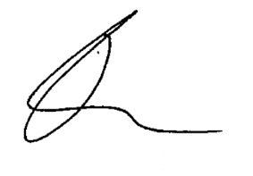

Travis Maher
Managing Director

Date: 22 October 2025

